Week 6

Thanh Minh

**Task 1:**

1. Text

   Description automatically generated
2. [Link to mercury](https://mercury.swin.edu.au/cos10026/s103809048/lab06/myfirst.php)
3. Text

   Description automatically generated

**Task 2:**

1. Text

   Description automatically generated
2. Text

   Description automatically generated
3. Text

   Description automatically generated
4. 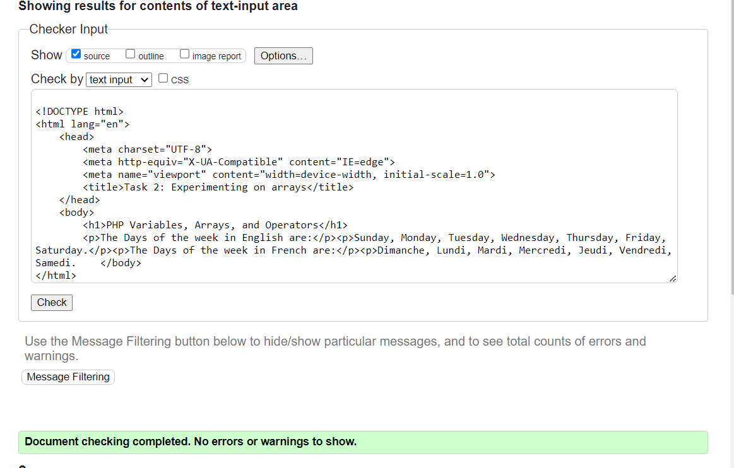

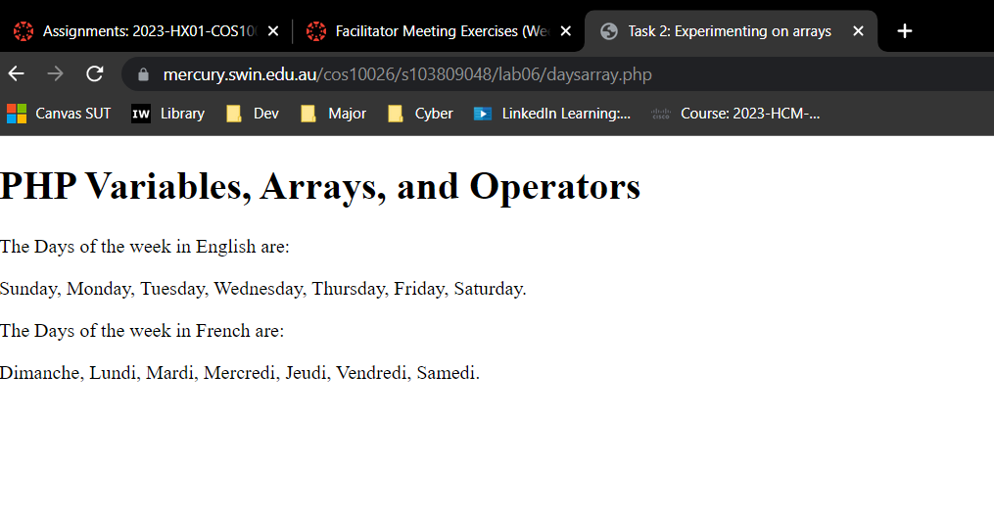

[Link to mercury](https://mercury.swin.edu.au/cos10026/s103809048/lab06/daysarray.php)